

**Subject- Application Of ML Lab**

**Lab Report**

**Submitted By Submitted To**

**Priyanshu Raj Ms. Pallabi Sharma**

**500097036**

**R2142211236**

**B.Tech CSE (AIML) NH B6**

**Application of ML in Industries**

**Assignment 1**

**Introduction to Panda**

**Task 1: Basic DataFrame Operations**

1. Download a dataset of your choice (CSV, Excel, or any other format). And load the dataset into a Pandas DataFrame.

CODE and OUTPUT:



1. Display the first 5 rows of the dataset. Check for missing values and handle them appropriately. Get a summary of the dataset using **describe()**.

CODE and OUTPUT:

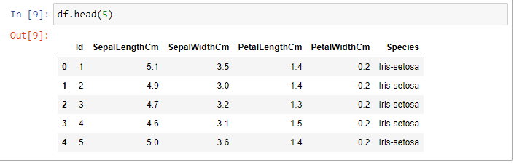

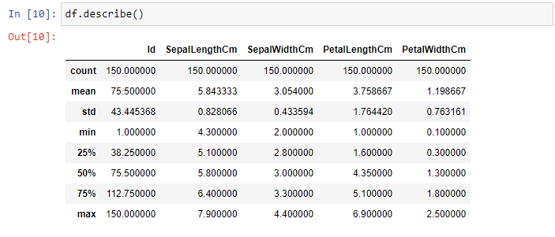

1. Select a subset of columns from the DataFrame. Use both label-based and position-based indexing. Create a new DataFrame by filtering rows based on a condition.

CODE and OUTPUT:

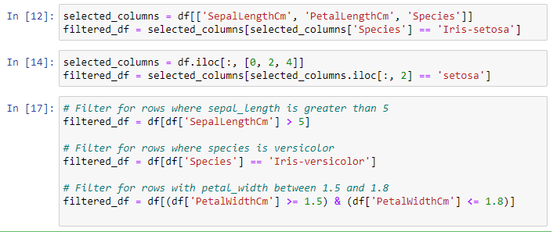

**Task 2: Data Cleaning and Preprocessing**

1. Identify missing values in the dataset. Decide on a strategy to handle missing values (e.g., imputation or removal). Implement the chosen strategy and explain the reasoning.

CODE and OUTPUT:

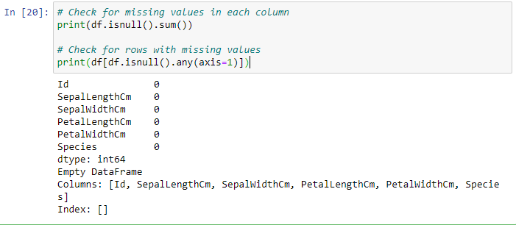

1. Create a new column by applying a mathematical operation on existing columns. Convert a categorical variable into numerical representation (e.g., using one-hot encoding).

CODE and OUTPUT:

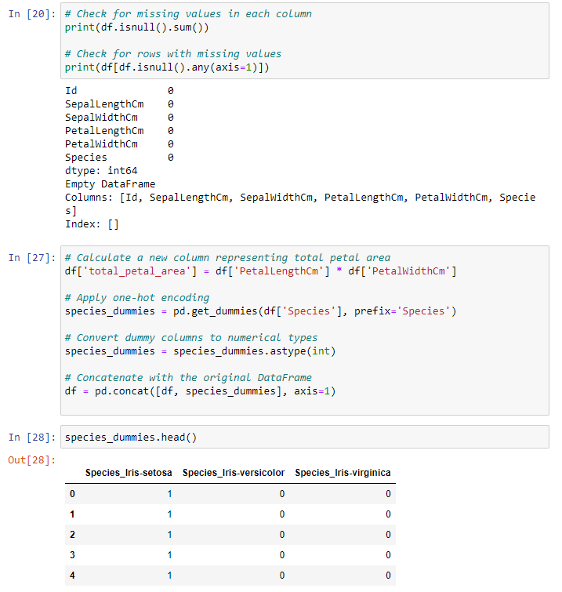

1. Group the data by a specific column. Apply aggregation functions (sum, mean, count) to the grouped data. Present the results in a meaningful way.

CODE and OUTPUT:

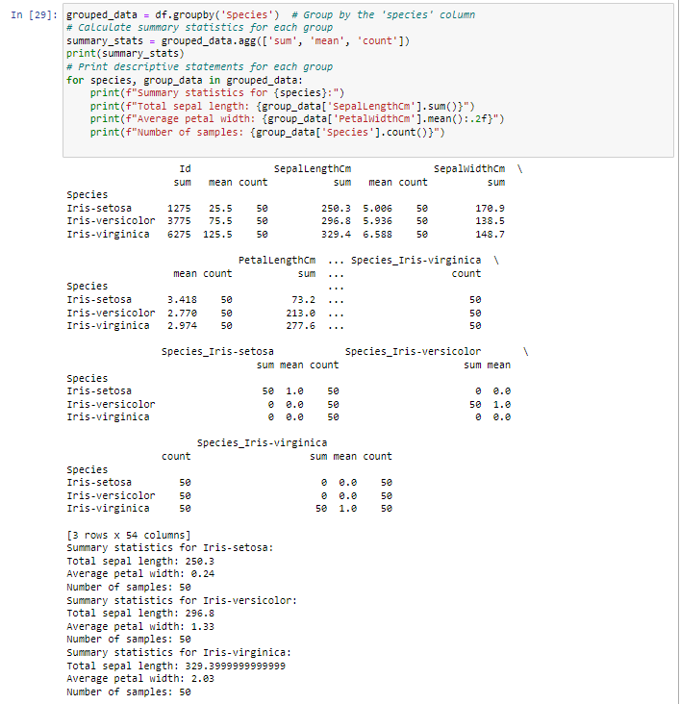

**Task 3:** Load two different datasets. Merge them using different types of joins (inner, outer, left, right). Analyze the impact of each type of join on the merged dataset.

**Task 4: Visualization**

1. Create a bar plot, line plot, and scatter plot using Pandas plotting functions. Customize the plots to make them more informative.

CODE and OUTPUT:

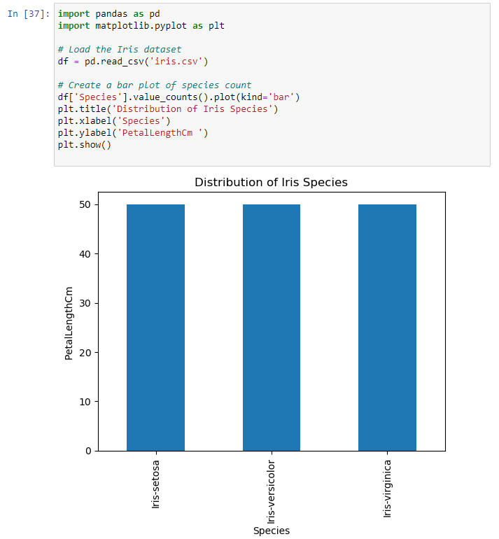

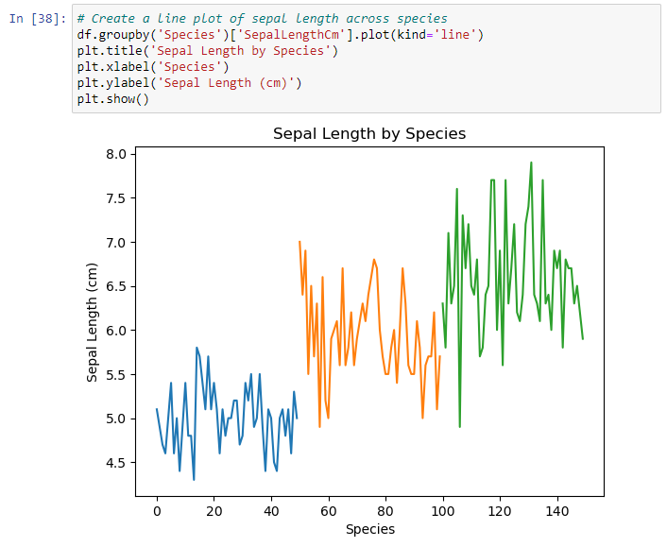

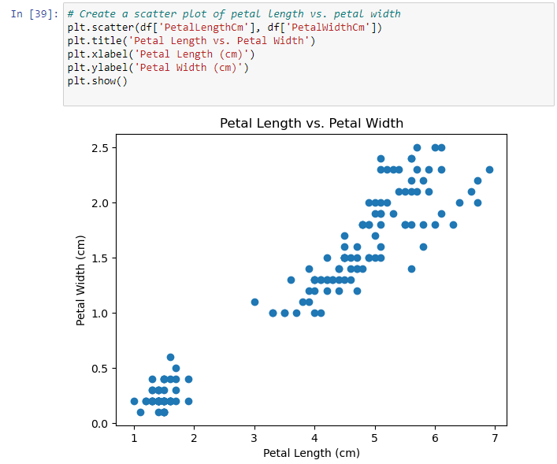

1. Visualize the correlation matrix of numerical columns. Highlight highly correlated features.

CODE and OUTPUT:

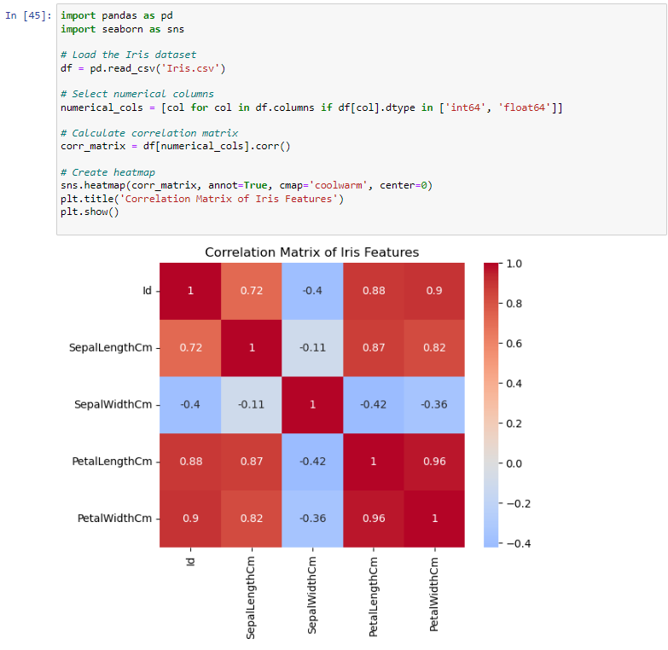

1. Create histograms and box plots for numerical columns. Analyze the distribution and presence of outliers

CODE and OUTPUT:

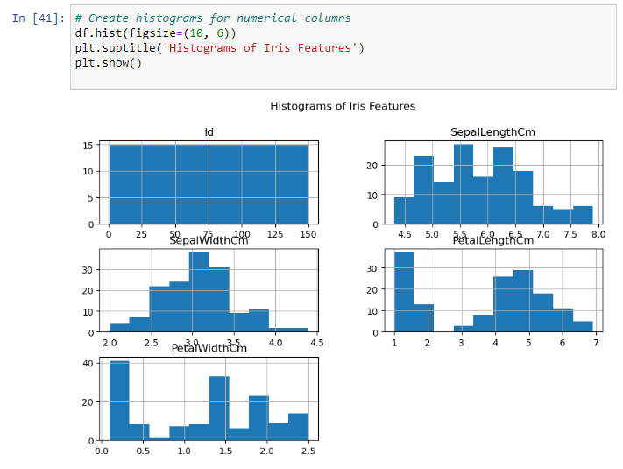

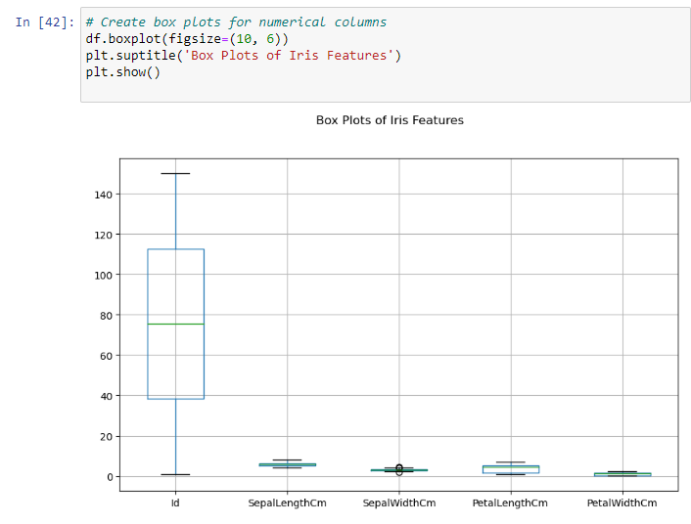

**Exploring NumPy**

**Task 5: Basic NumPy Operations**

1. Create a NumPy array 'arr' with values from 1 to 10.
2. Create another NumPy array 'arr2' with values from 11 to 20.
3. Add, subtract, multiply, and divide 'arr' and 'arr2'. Print the results.

CODE and OUTPUT:

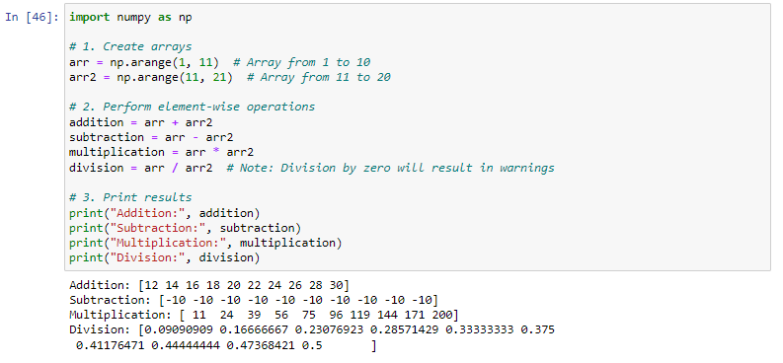

**Task 6: Array Manipulation**

1. Reshape 'arr' into a 2x5 matrix.
2. Transpose the matrix obtained in the previous step.
3. Flatten the transposed matrix into a 1D array.
4. Stack 'arr' and 'arr2' vertically. Print the result.

CODE and OUTPUT:

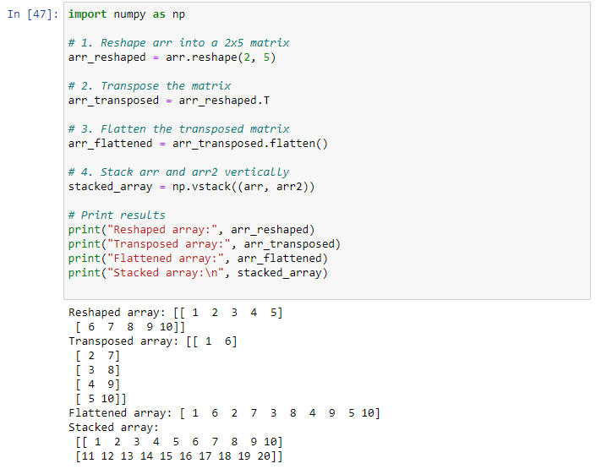

**Task 7: Statistical Operations**

1. Calculate the mean, median, and standard deviation of 'arr'.
2. Find the maximum and minimum values in 'arr'.
3. Normalize 'arr' (subtract the mean and divide by the standard deviation).

CODE and OUTPUT:

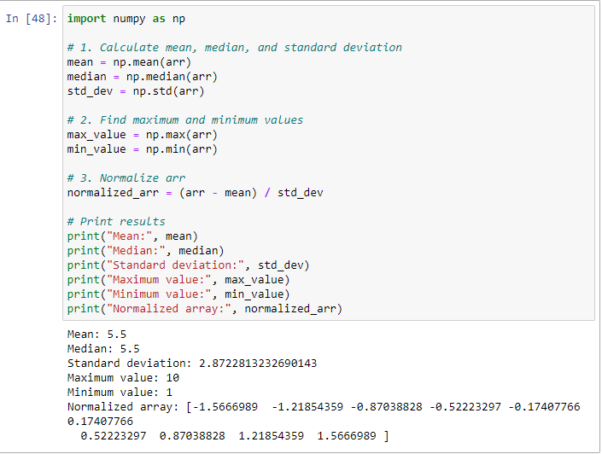

**Task 8: Boolean Indexing**

1. Create a boolean array 'bool_arr' for elements in 'arr' greater than 5.
2. Use 'bool_arr' to extract the elements from 'arr' that are greater than 5.

CODE and OUTPUT:

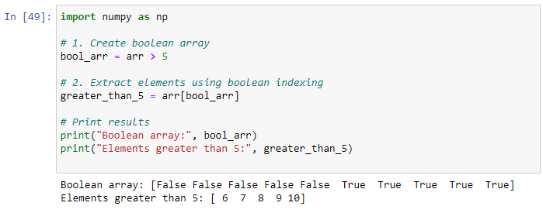

**Task 9: Random Module**

1. Generate a 3x3 matrix with random values between 0 and 1.
2. Create an array of 10 random integers between 1 and 100.
3. Shuffle the elements of 'arr' randomly.

CODE and OUTPUT:

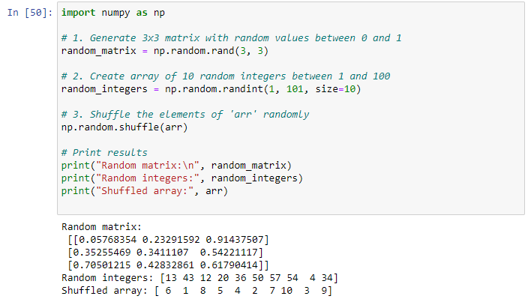

**Task 10: Universal Functions (ufunc)**

1. Apply the square root function to all elements in 'arr'.
2. Use the exponential function to calculate ex*ex* for each element in 'arr'.

CODE and OUTPUT:

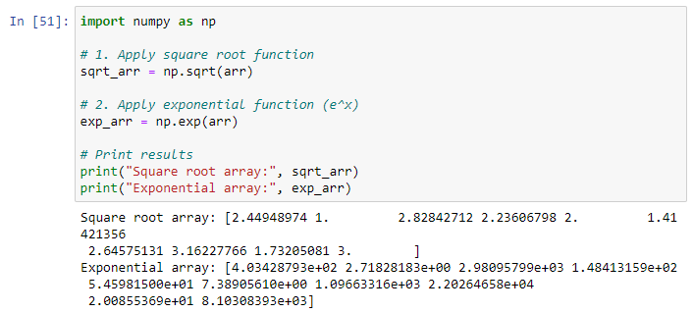

**Task 11: Linear Algebra Operations**

1. Create a 3x3 matrix 'mat_a' with random values.
2. Create a 3x1 matrix 'vec_b' with random values.
3. Multiply 'mat_a' and 'vec_b' using the dot product.

CODE and OUTPUT:

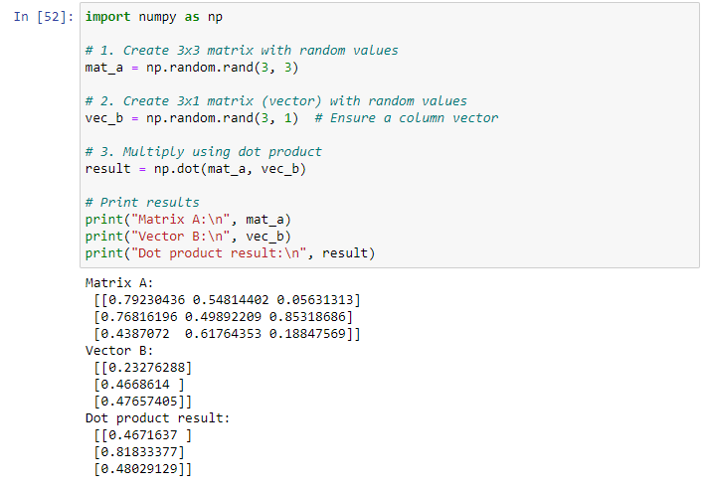

**Task 12: Broadcasting**

1. Create a 2D array 'matrix' with values from 1 to 9.
2. Subtract the mean of each row from each element in that row.

CODE and OUTPUT:

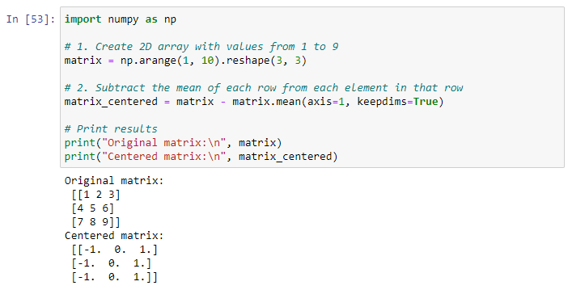

Application of ML in Industries

Assignment 2

Wine price Prediction

CODE:

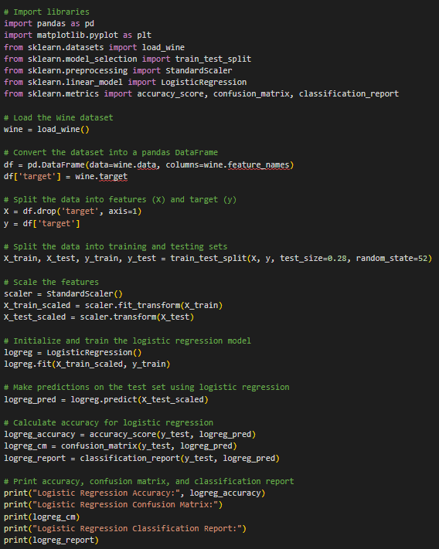

OUTPUT:

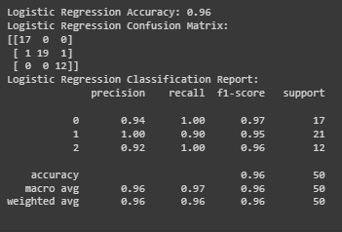

Application of ML in Industries

Assignment 3

House price Prediction

CODE:

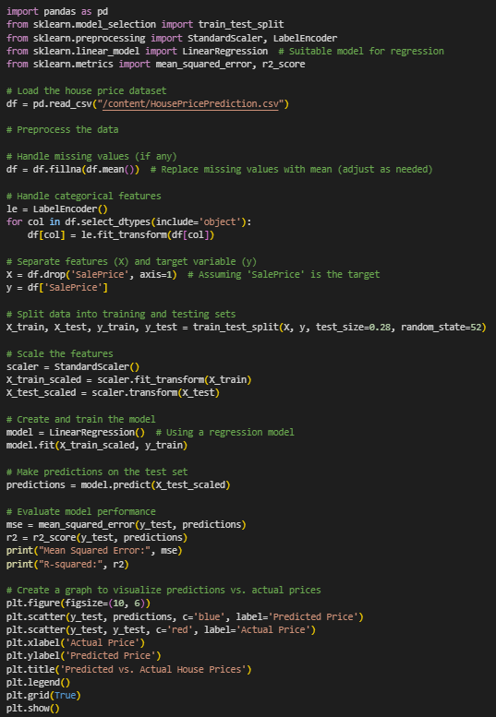

OUTPUT:

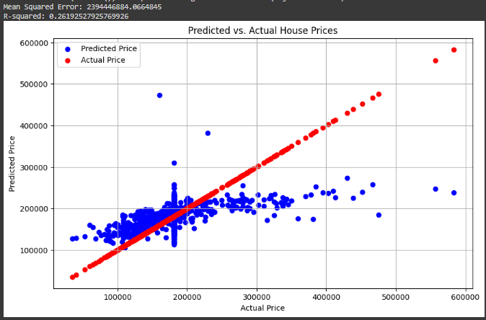

Application of ML in Industries

Assignment 4

AirQuality Prediction

CODE & OUTPUT:

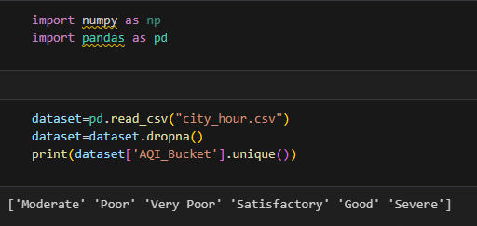

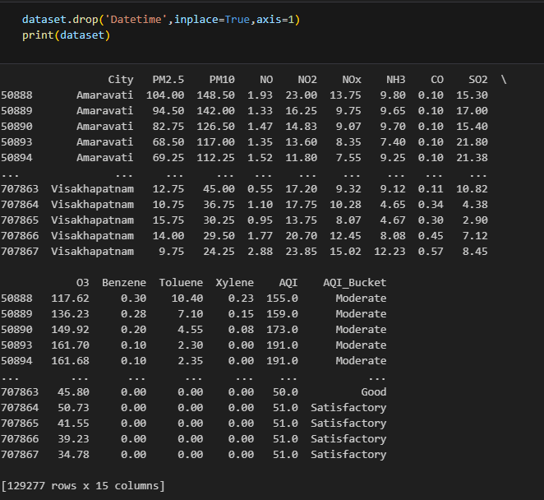

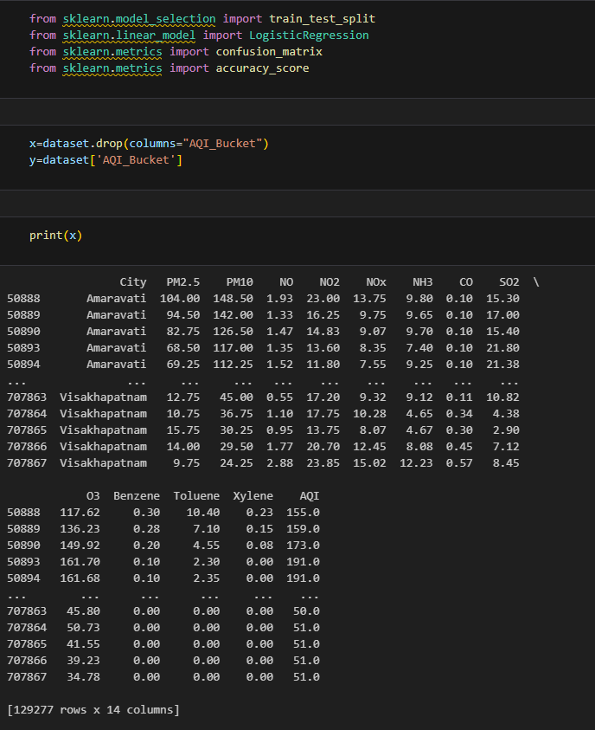

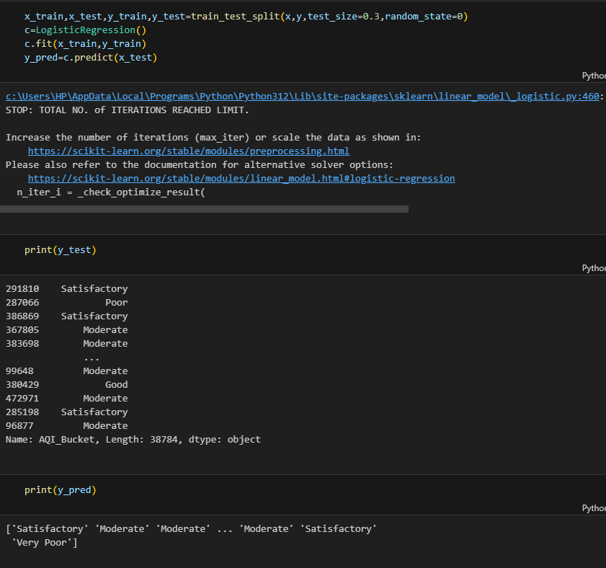

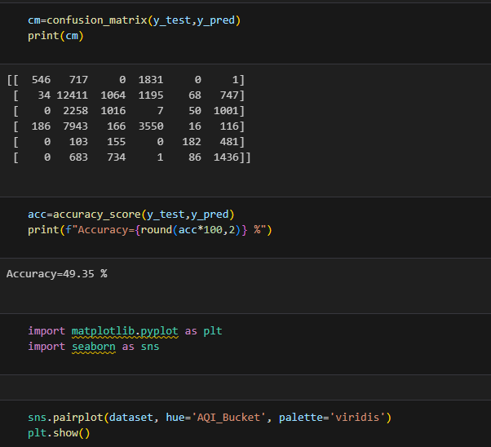

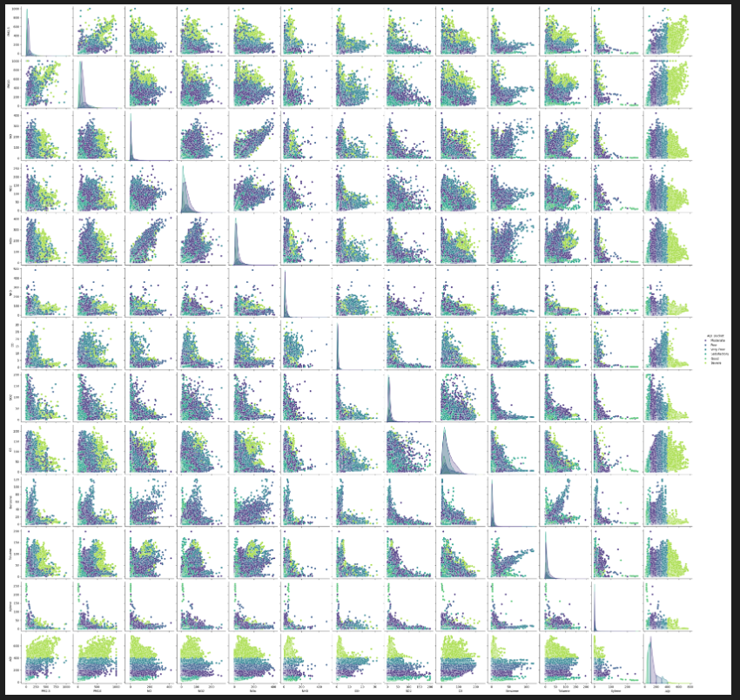

Application of ML in Industries

Assignment 5

Credit Card Prediction

CODE & OUTPUT:

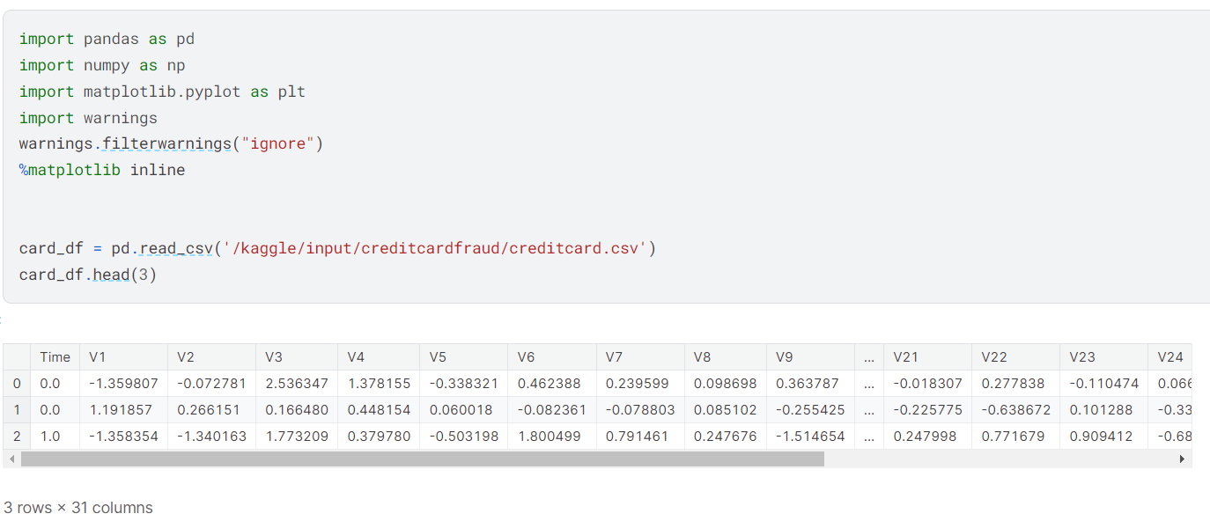 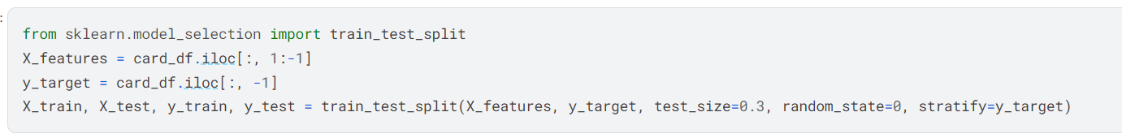

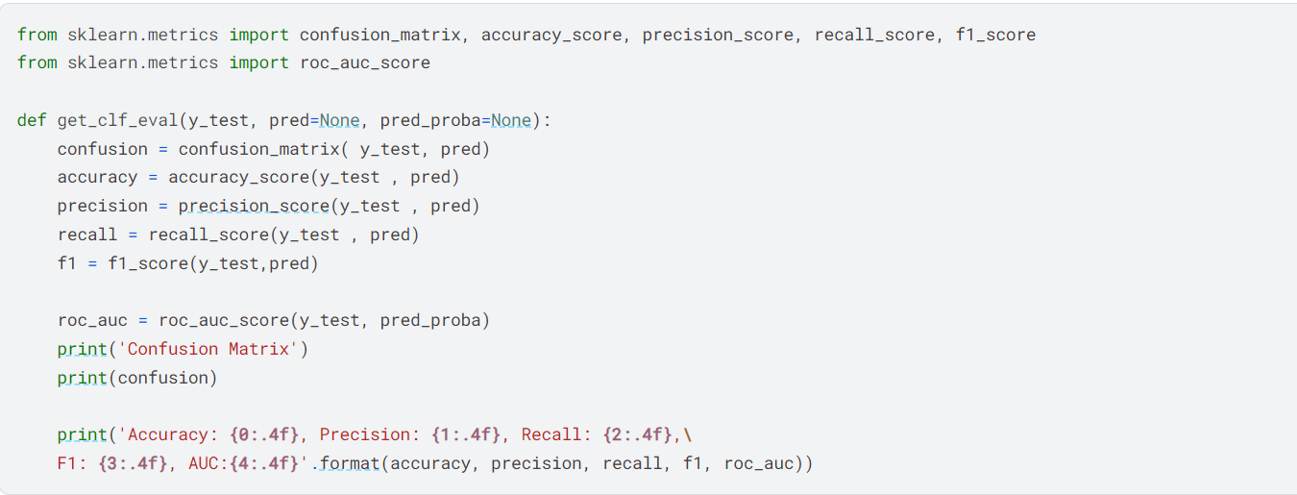

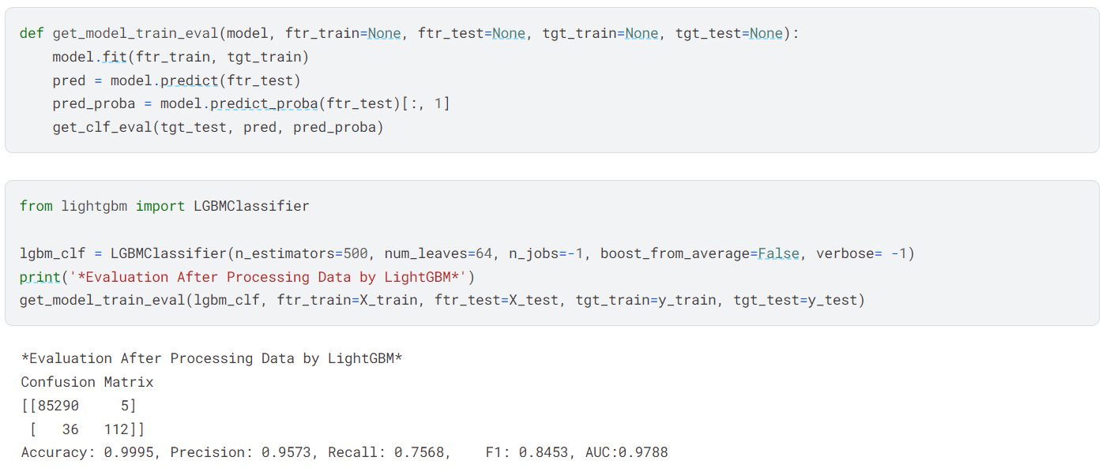

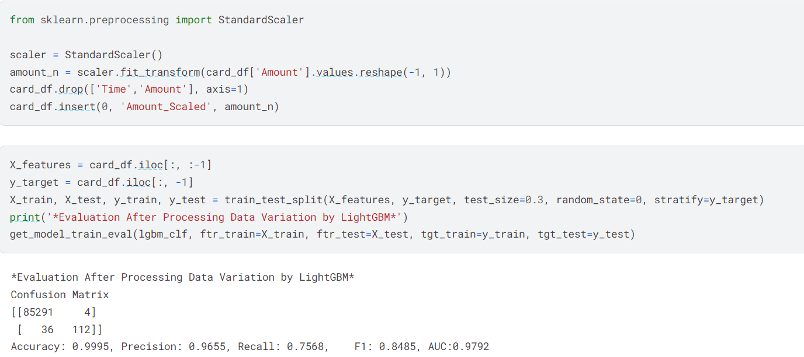

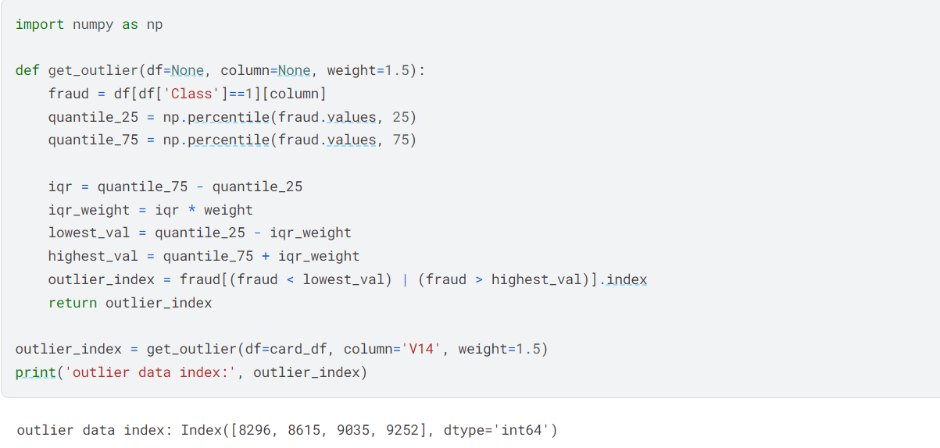 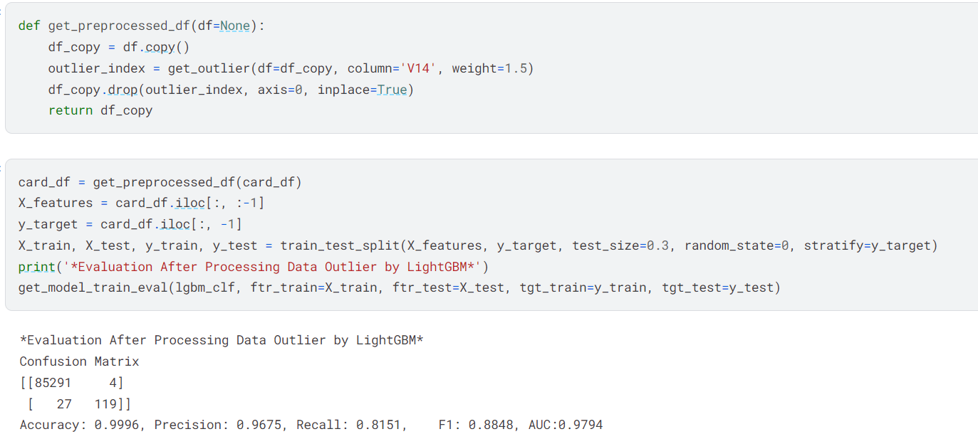

Application of ML in Industries

Assignment 6

Hypothesis Testing

CODE:

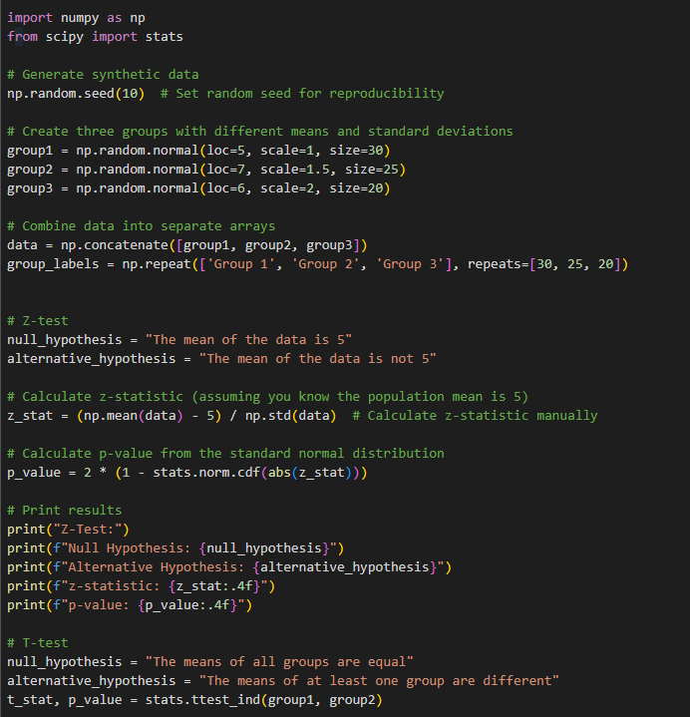

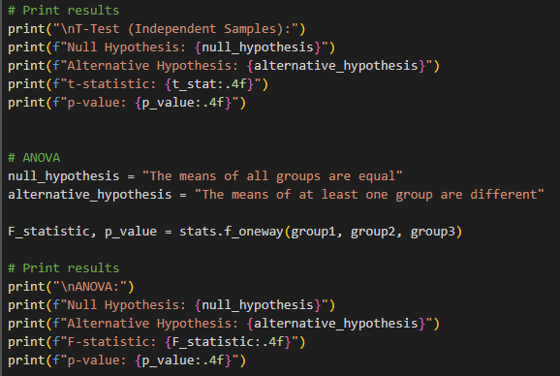

OUTPUT:

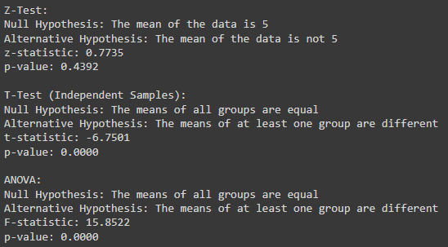

Application of ML in Industries

Assignment 7

CIFAR 10

CODE:

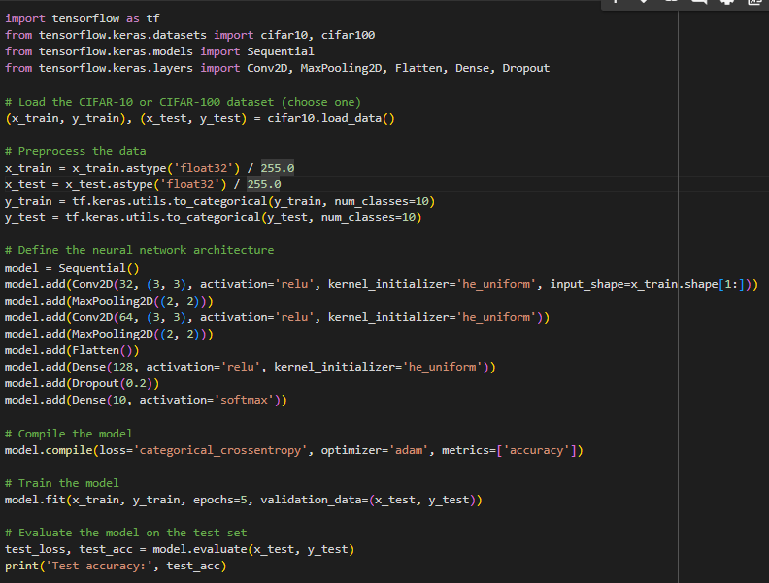

OUTPUT:

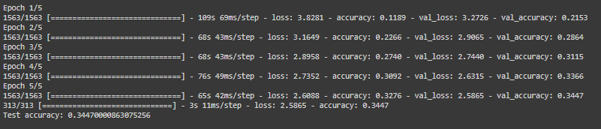

CIFAR 100

CODE:

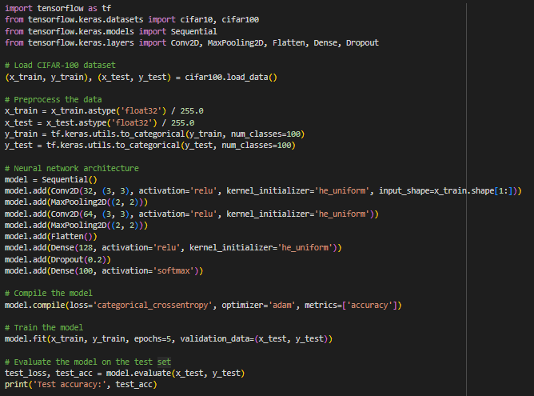

OUTPUT:

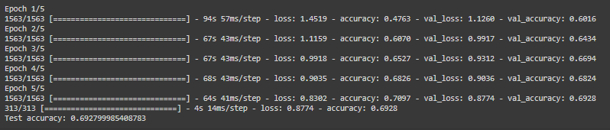

Application of ML in Industries

Assignment 8

To compare Simple neural network and deep learning model

CODE & OUTPUT:

